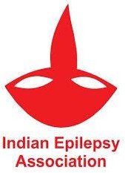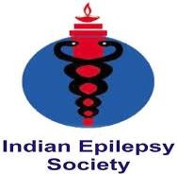

EPIACT India SAP Initiative Survey
Dear Colleagues,
As part of the EPIACT–India project on Seizure Action Plans (SAPs) and Rescue Medication Implementation, we are conducting a short survey to gather valuable inputs from professionals and stakeholders across different levels of epilepsy care.
This survey aims to:
• Understand current practices and challenges in seizure emergency management across healthcare tiers.
• Identify gaps in the use of rescue medications and seizure action plans.
• Collect expert opinions to guide the design of a nationally relevant, evidence-based SAP template and implementation model.
Help us shape the future of seizure emergency care and the development of Seizure Action Plans (SAPs) in India. Your insights and experience can make a meaningful difference in how seizure emergencies are managed across all levels of care.
The survey will take only 2–3 minutes to complete.
Your participation will be invaluable in shaping a consensus-based, practical, and scalable seizure emergency framework for India.
📎 https://www.surveymonkey.com/r/ZS2MGTY

Be a part of this national movement and contribute to changing the landscape of seizure emergency care in India.
We value your opinion — your insights will help shape the future of Seizure Action Plans in India.
For further details contact us:
sgiea2017@gmail.com | balveen_singh@yahoo.co.in
Your perspective will help make this initiative both evidence-driven and contextually meaningful.

